Code Optimization

Good code:
- Correct (most important)
- Readable and flexible code
- Fast
- Doesn’t take up too much memory (least important)

Optimization strategy:
- Enable compiler optimization flags. -O2 is best
- Run/profile code (time different segments) to determine if its performance is sufficient
- Improve algorithms (learned from CSE 214/260)
- Do hardware optimization

Optimization Tools

time a.out
- Real (wall time): How much real-world time passed
- User: How much time your program spent running (excluding OS)
- System: How much time the OS spent running
If wall time > CPU time, then it might be an I/O problem

Profiling: Helps you understand program performance
- Execution profile: How much time spent in each function. Stack trace to identify hot spots
- Heap allocation profile
- How it works: Direct timing (accurate but slows down code), and OS sampling

gprof (GNU Profiler): https://sourceware.org/binutils/docs/gprof
- gcc -pg main.c
- Run program normally (generates gmon.out)
- Use gprof to produce a report

The lecture slides contain more tools

Hardware Optimizations

Hardware optimizations:
- Dead code elimination
- Code motion
- Reduction in strength
- Sharing common subexpressions
- (Removing) memory aliasing
- Loop unrolling
- Function inlining / Reducing procedure calls

Code motion: Move repeatedly calculated variables that don’t change value outside of loops:
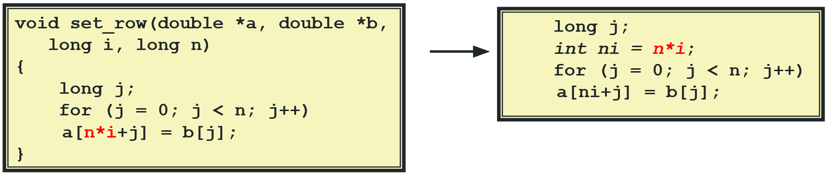

Reduction in strength: Here, uses addition (faster) instead of multiplication (slower)
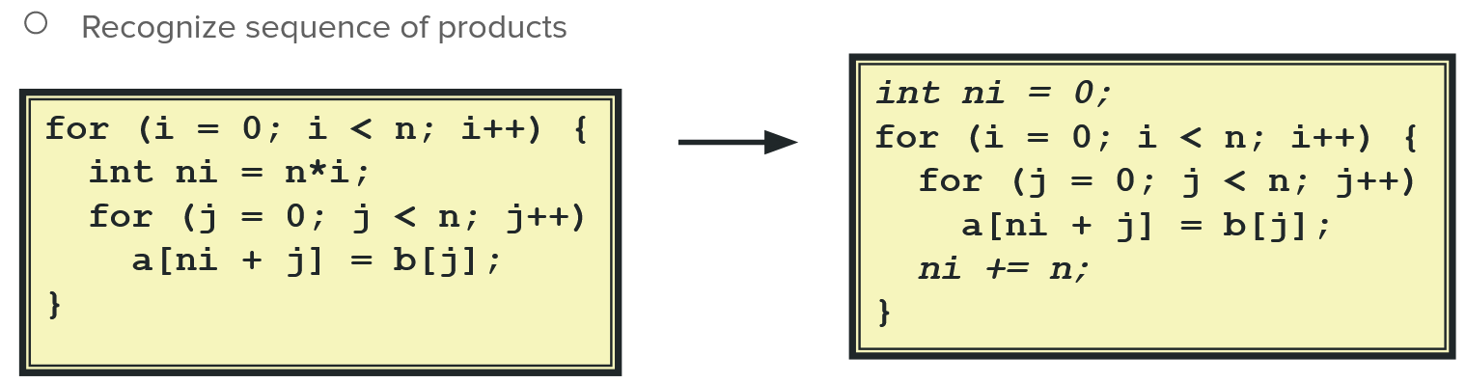

Sharing common subexpressions: Calculating commonly used variables once
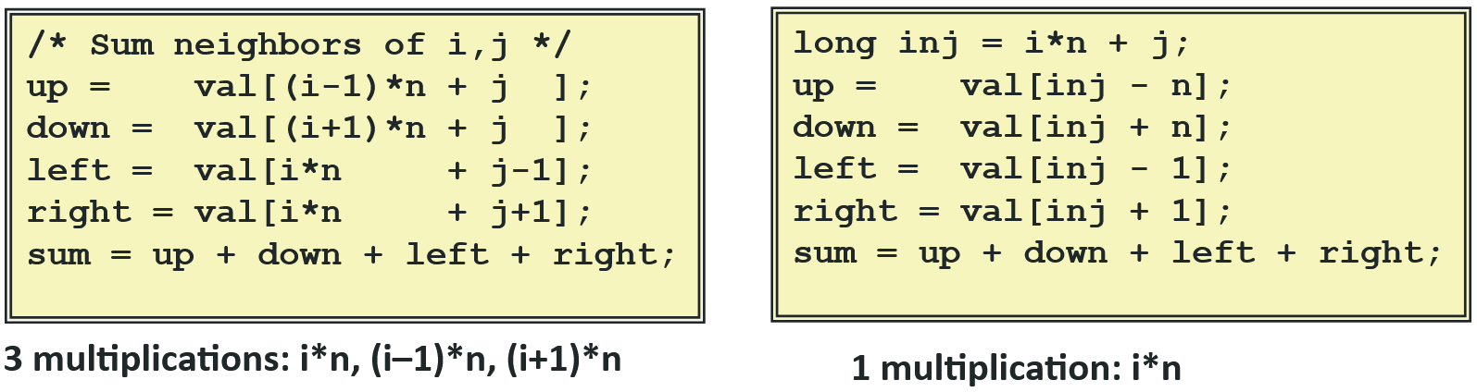

Optimization blockers: Things the compiler cannot optimize
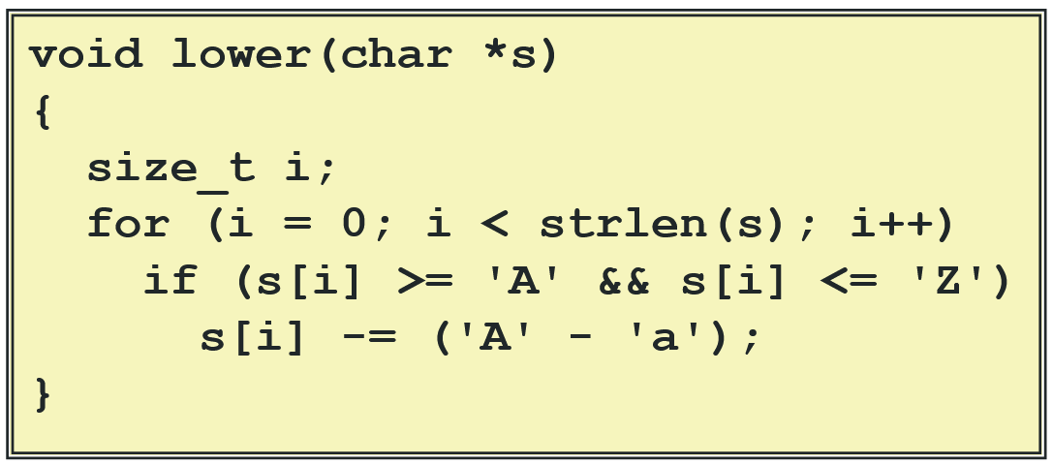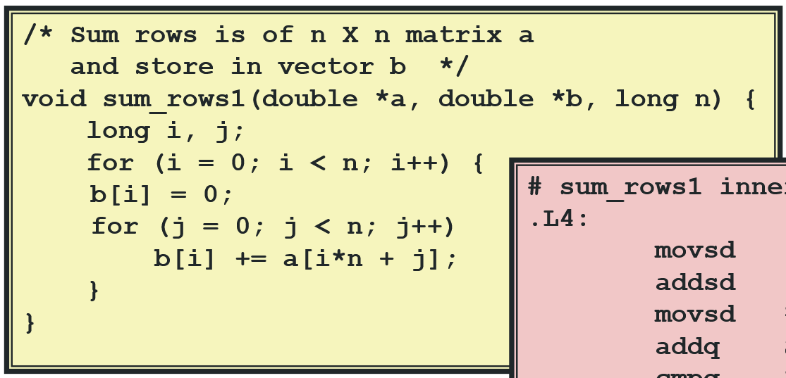
Left: strlen() is a blackbox; compiler cannot replace it with something else
Right: The compiler cannot assume that a[] and b[] do not overlap addresses
Now there are actual hardware level optimizations (hardware knowledge required). See the slides here for loop unrolling
- Latency bound (sec): Time for operation X to execute. e.g. integer multiplication takes 3 clock cycles. Lower is better
- Throughput bound (ops/sec): Maximum possible number of operations X per second. Uses all hardware available. For instance, all 4 multiplication units are working. Higher is better

Principle of Locality

Principle of Locality: Programs like to use data and instructions with addresses near or equal to those used recently
- Temporal locality: Recently referenced things are likely to be referenced again in the near future
- Spatial locality: Items with nearby addresses tend to be referenced close together in time
- These are true because of a cache (we will learn about this soon)

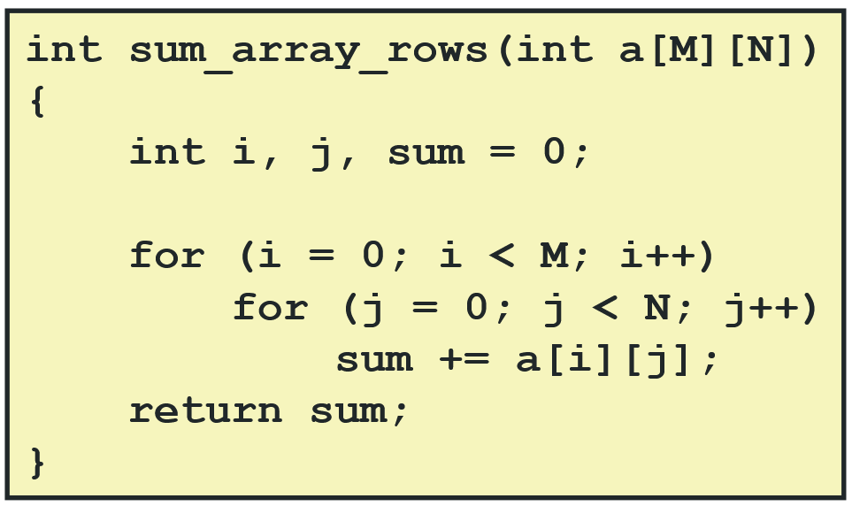

In this example, doing a[i][j] is better than a[j][i] because if you do a[j][i], then you jump around a lot because a[i] moves by N ints after each iteration (not spatially local)

Types of Memories

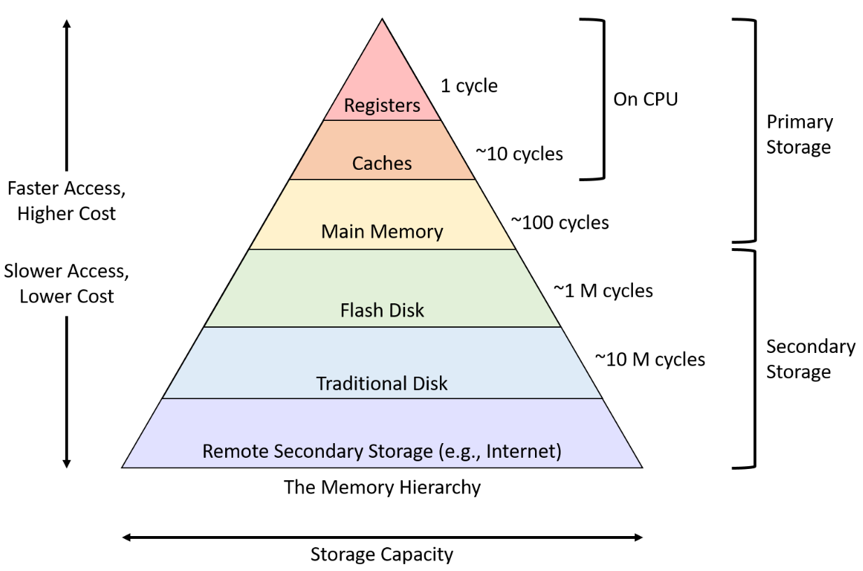

Dimensions: Speed, size, cost ($), power consumption
- In CSE 220, our load/store instructions actually access the cache, not main memory
- We will not cover remote secondary storage in this course

Memories:
- RAM (“main memory”)
  - Static RAM: Used for the cache. Power-efficient and fast, but small and expensive ($)
  - Dynamic RAM: Used for main memory. Slow and has high power consumption, but is larger and cheaper ($)
  - Both SRAM and DRAM are volatile and are lost when you turn off your machine
- SSDs (solid state drives, a middle ground between disk and RAM)
- HDDs (Hard disk drives, “Disk”)
Other (nonvolatile): Read-only, programmable ROM, erasable PROM, electrically erasable PROM, flash memory: EEPROM

Key idea: Good programmers keep commonly used memory near the CPU and less commonly used memory below
- Following the principles of locality makes it more likely to keep commonly used memory in/near the registers and caches

Disk (HDD)
The disk:
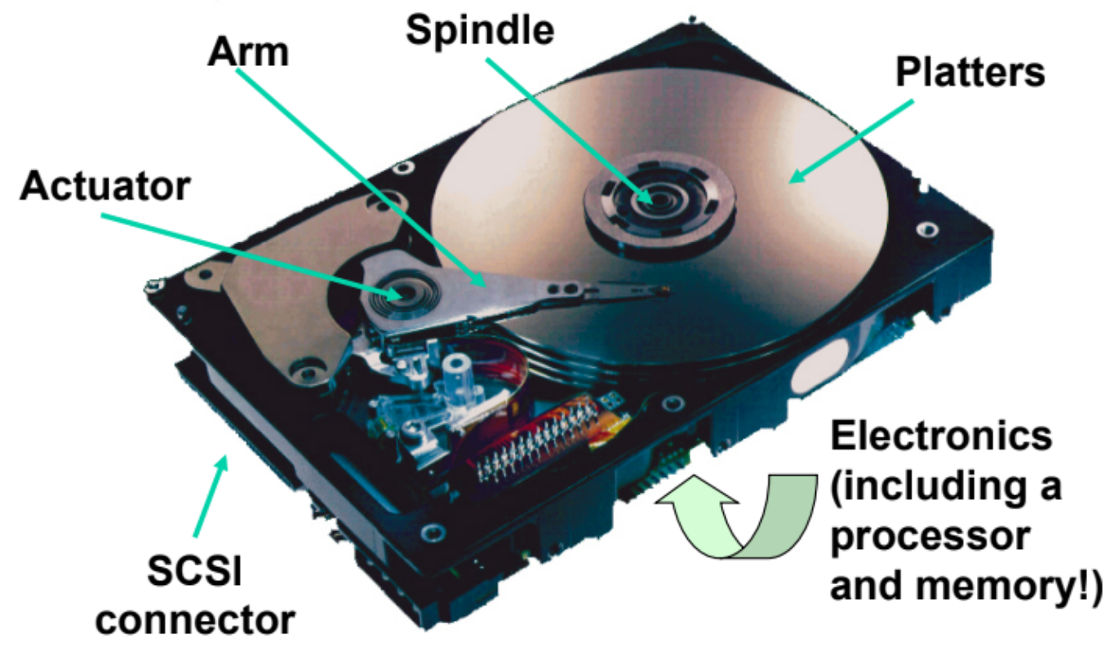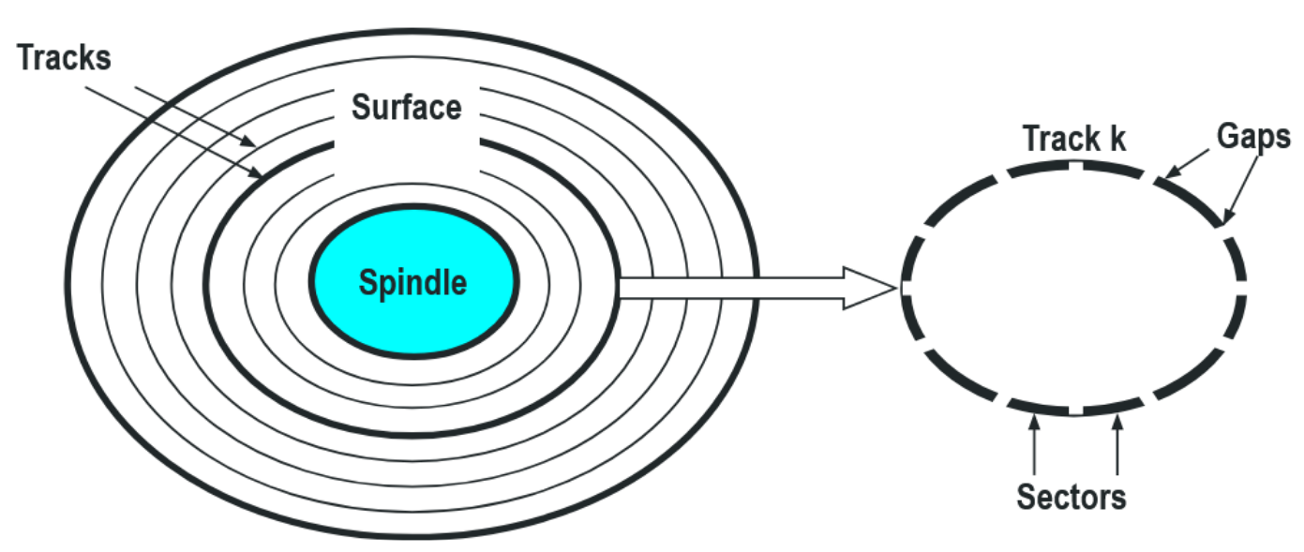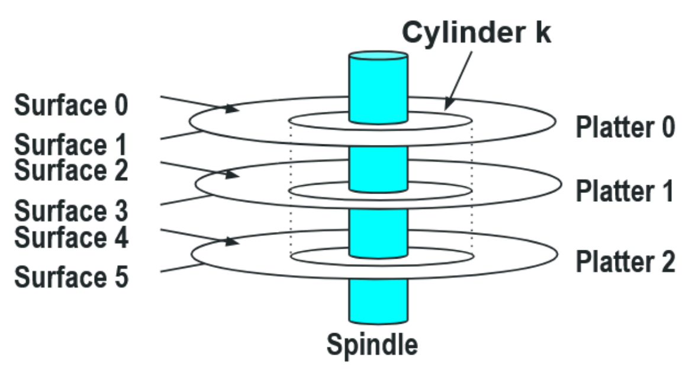

- Disks consist of platters. They have 2 surfaces: Top and bottom
  - The arm has heads that reach every single surface
  - Damaged platters are managed accordingly by other hardwares
- Each surface has tracks (like track and field lanes)
- Each track is divided into sectors (there are gaps between sectors)
  - Outer tracks have more sectors than inner tracks
  - Aligned tracks form a cylinder (not useful for upcoming calculations)

Capacity: Number of bytes that can be stored. Determined by:
- Recording density (bits/in): # of bits squeezed into a 1 inch segment of a track
- Track density (tracks/in): # of tracks that can be squeezed into a 1 inch radial segment
- Areal density (bits/in2): Product of recording and track densities
(# bytes/sector) * (avg # sectors/track) * (# tracks/surface) * (# surfaces/platter) * (# platters/disk)
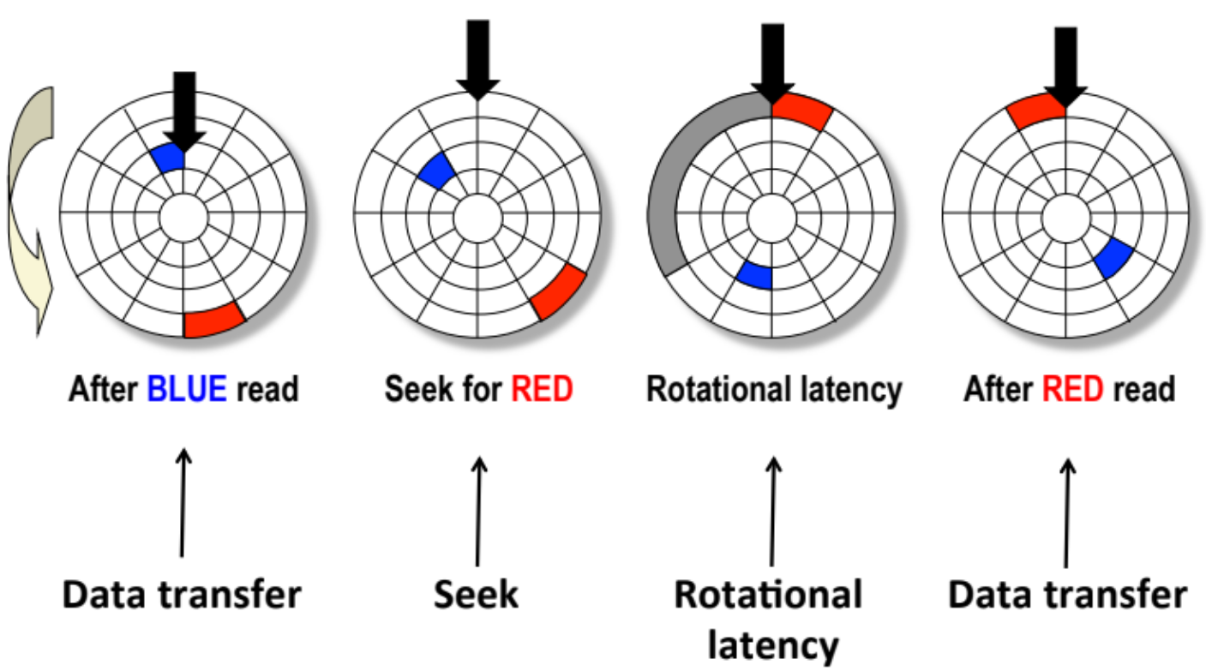
Read from disk:
- Seek: Move the arm to the correct track
- Rotation: Let the platter spin to the correct sector (very slow)
- Transfer: Let the platter spin while the arm reads
Access time = Seek + Rotation + Transfer

Average rotation time = ½ * (1/RPM) * (60 sec/ 1 min)
Average transfer time = (1/RPM) * 1/(avg # sectors/track) * (60 secs/1 min)

There’s a mapping between logical blocks and physical sectors. CPU looks at logical blocks and then the disk moves to the corresponding sector. CPU does not control the disk

I/O Bus

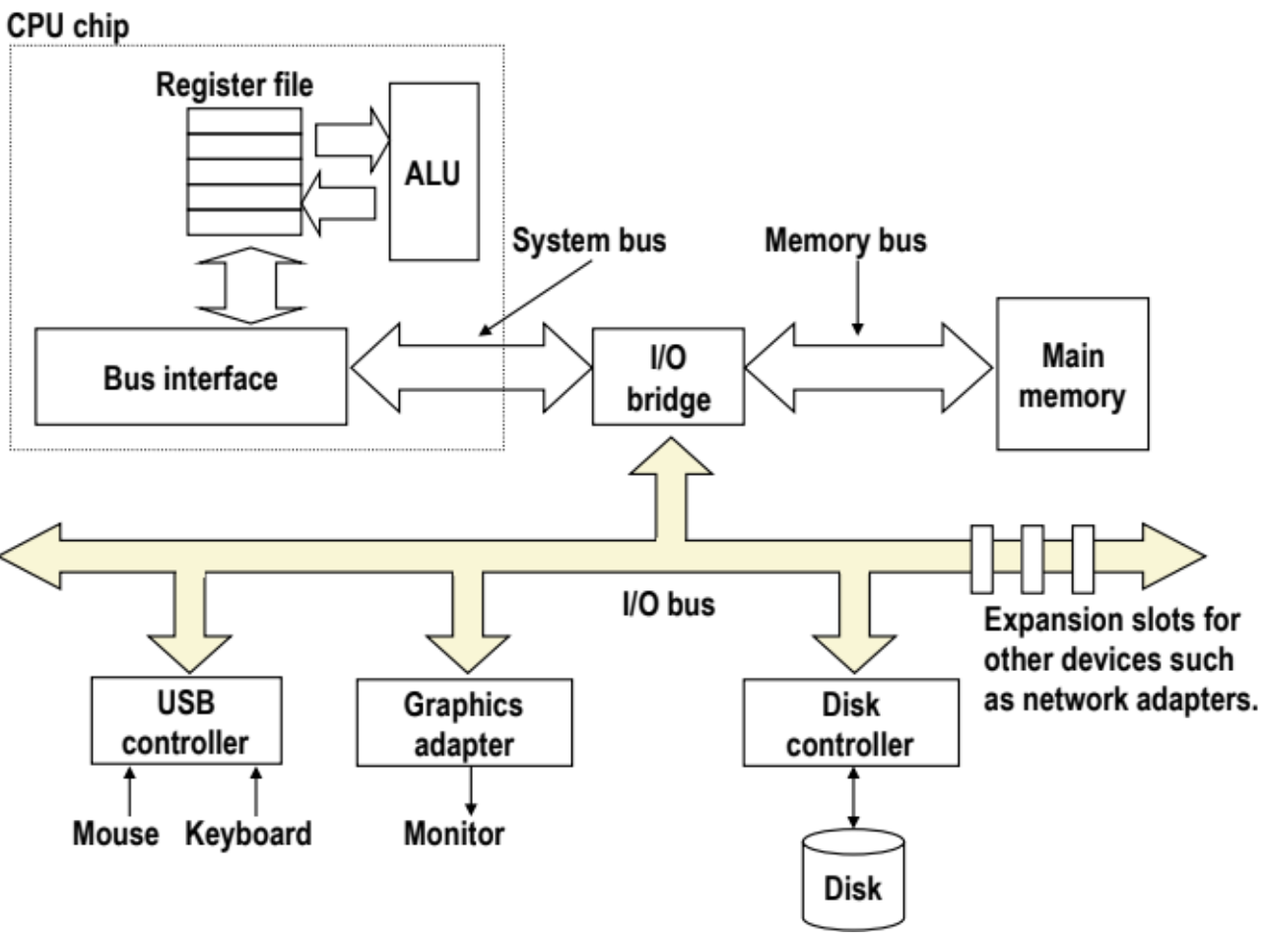
DMA bulk copies data to/from main memory to the disk. Like memcpy
- The CPU does not have to do any of this
IRQ: Works like an alarm. Basically the CPU is minding its own business when an I/O event (like mouse click) occurs and sends the interrupt signal to the CPU. Then the CPU will figure out what it’s retrieving from the I/O bus and act accordingly
- Polling: CPU consciously and consistently checks for interrupt. Useful for GeoDash

Solid State Disk (SSD)

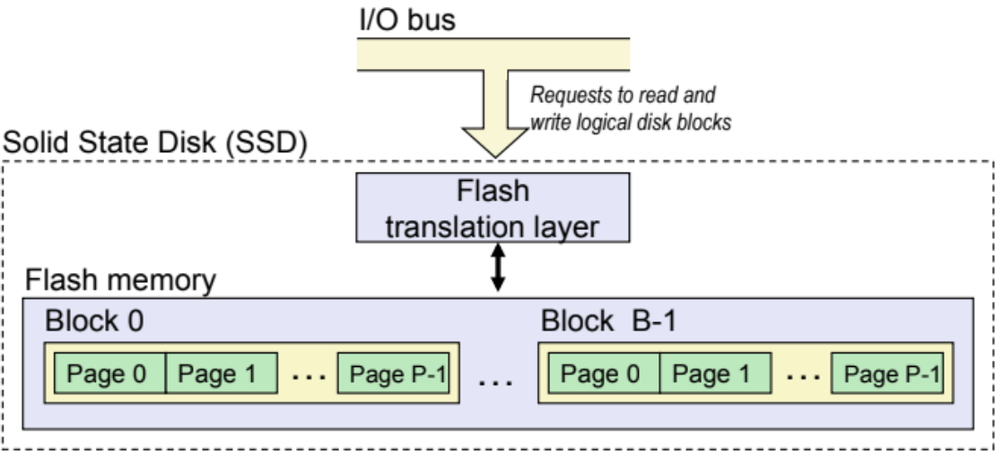

- Blocks wear out after ~100,000 writes. Afterwards, they can only be read, not written to
- Data is read/written in whole pages
  - Pages can only be written to once its block is erased
- Sequential access is faster than random access
- Random writes are somewhat slower
  - Erasing a block takes a long time (~1 ms)
  - Modifying a block page requires all other pages to be copied to new block

SSDs have no moving parts. Faster than HDDs and actually consume less power (because no moving parts). However, they wear out and are more costly ($).

Caches
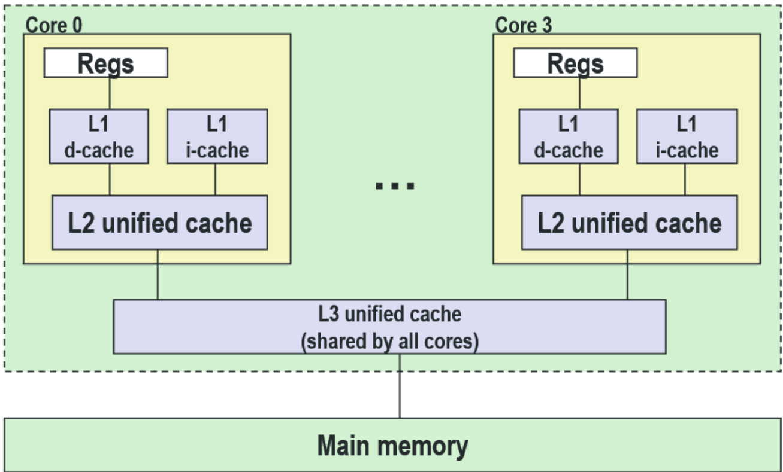

Caches exist between the CPU and RAM
- Hits (cache has it)
- Misses (cache doesn’t have it. Then...)
  - Placement policy (where does new block go)
  - Replacement policy (which block gets evicted)
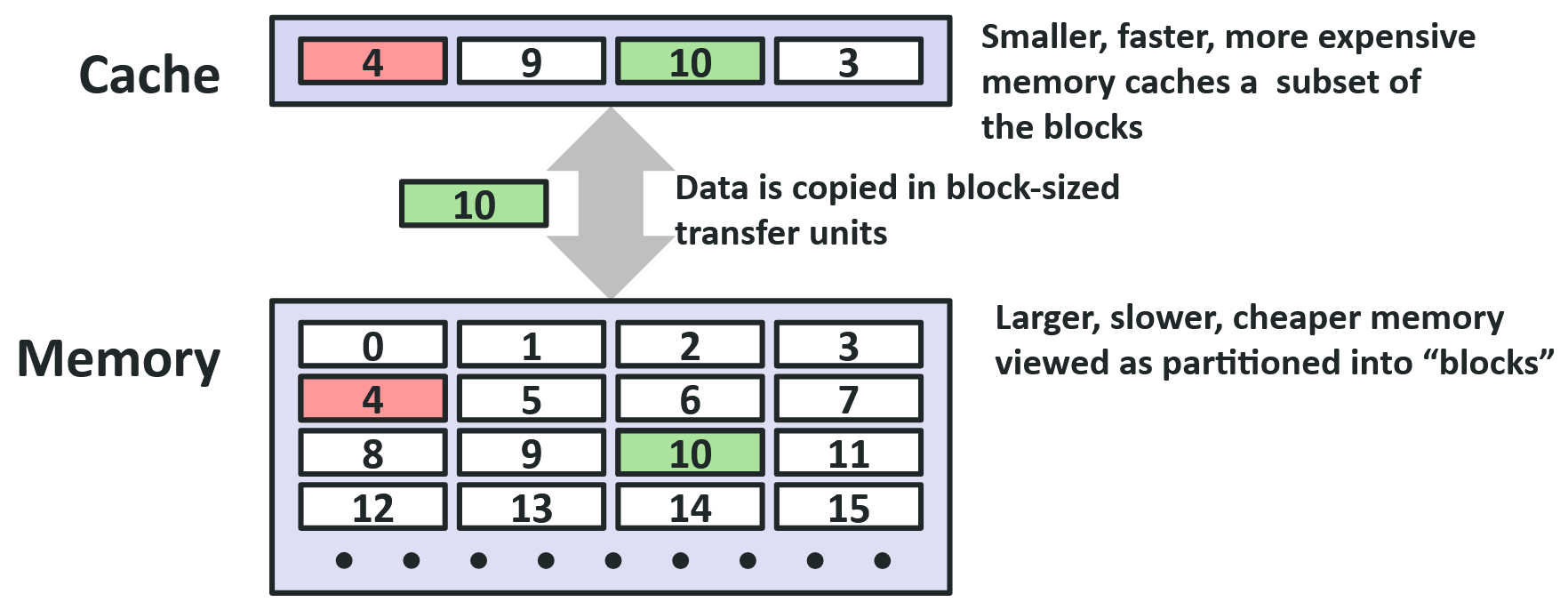

Types of cache misses:
- Cold miss: Cache block is empty (valid = 0)
- Conflict miss: In the above diagram, 10 and 14 can only be stored in that same block. Calling 10, 11 is fine, but 10, 14, 10, 14 is bad (engineer’s duty)
- Capacity miss: There are more active cache blocks than the cache (programmer’s duty)

Mapping RAM to cache:
- Extreme 1: Directly mapped (the 10 14 example). Lines = 1
- Extreme 2: Fully Associative: RAM blocks can go anywhere in cache. Sets = 1
- Middle ground: Set-associative: Every address in RAM has 1 cache set that it can use. However, it can use any line within said set

Cache layout (regardless of mapping):
- There are S sets
- Each set contains E lines
- Each line contains a valid bit, a tag, and a block B that holds the actual data
- S, E, and the number of bytes within B are all powers of 2
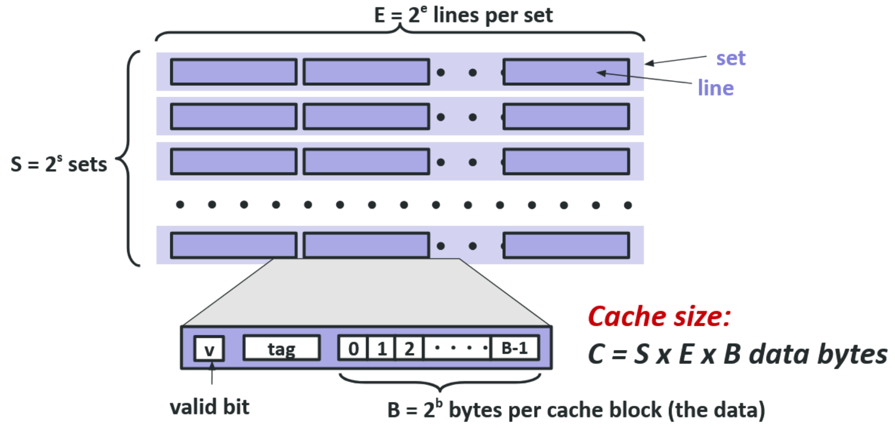
When an instruction accesses data from main memory, it first checks if it exists in the cache. The address of said data is split into: Tag, index, offset
- Use index to locate the corresponding set
- Go through all lines in said set
- If a line’s tag matches the address’ tag AND the valid bit = 1, then cache hit. We take the data from the line’s block (0 + offset)
- The valid bit is 0 upon machine startup and is permanently 1 once the line gets placed
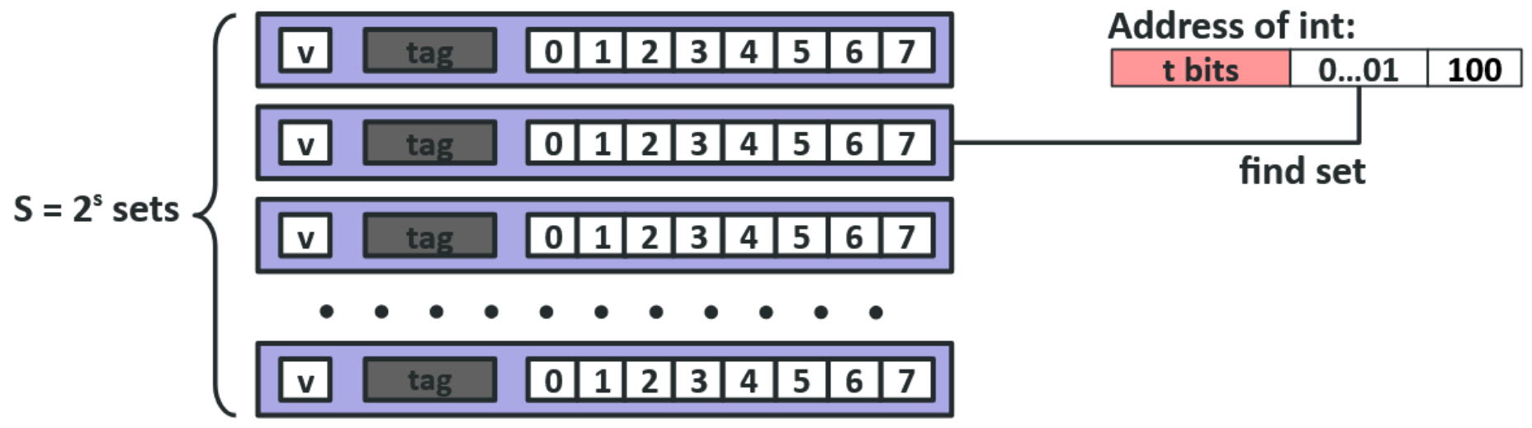
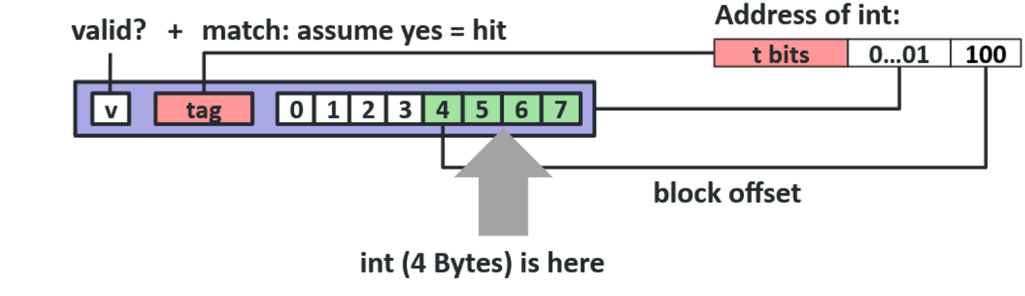

Upon a cache miss, data is read from RAM as follows: [tag | set | # of bytes]
- The # of bytes asked is the same as the size of the cache blocks
- Reading a single byte from RAM is a waste of time. Why not read to the whole block?

Example using matrix multiplication: SLIDES
- By rearranging the i, j and k loops and traversing the matrices differently, we can use more spatial locality
- But the “standard” matrix multiplication requires traversing each element n times
- So we divide the matrices into submatrices so they fit into the cache once, multiply submatrices, place them in matrix C, evict them and never use them again

Writes

If I write to cache, when do I actually push it to RAM?
- Write-through (immediately write back to memory). Problem: Slow
- Write-back (wait until line gets evicted). Problem: Multiple cores working on the same address
  - Requires a dirty bit (“This block has been modified and must be written back”)

How about a write-miss? 2 options:
- Write straight to memory, skip the cache. OR
- Write-allocate (load into cache, update line in cache). Good if there will be more writes to this location

Typical implementations:
- Write-through straight to memory
- Write-back and write-allocate

Hit and Miss Metrics

- Miss rate and hit rate
- Hit time: Time to deliver a line in the cache to the processor. Includes time determining whether line is in the cache. Very fast
- Miss penalty: Very slow. Can take hundreds of cycles to access from RAM

How bad is a cache miss? Consider a 97% and 99% hit rate. Assume:
- Hit time: 1 cycle
- Miss penalty: 100 cycles
Average access time:
- 97% hits: 1 cycle + 0.03 * 100 cycles = 4 cycles
- 99% hits: 1 cycle * 0.01 * 100 cycles = 2 cycles
- Using miss rate instead of hit rate is more transparent

Linkers

Remember that a C program is compiled as:
- Preprocessor: Removes comments and expands macros. Outputs .i file
- Compiler: Turns preprocessed C code into assembly code. Outputs .s file
- Assembler: Turns assembly into machine code. Outputs .o, a relocatable object file
  - Shared object files (.so): Special type of relocatable object file that can be loaded into memory and linked dynamically, at either load time or runtime
  - Both .o and .so files contain a symbol table that’s actually an array of structs per symbol, each struct containing the symbol’s name, size and memory location.
  - More on symbols soon...
- Linker: Combines all necessary object files (like whatever was from stdio.c) into executable object file a.out (default name)
  - Linker performs symbol resolution, using symbol tables from the .o files, then afterwards it performs relocation

Executable and Linkable Format (ELF): Standard format for .o, executables and .so

ELF Format
Section | Contents
ELF header | Word size, byte ordering, file type (.o, exec, .so), machine type, etc.
Segment header table | Used for virtual memory. Page size, virtual addresses memory segments and their sizes
.text | Code
.rodata | String literals, immutable variables, read-only data, jump tables, etc.
.data | Initialized global variables
.bss | Uninitialized global vars. Has section header but occupies no space
.symtab | Symbol table, procedure and static variable names, section names and locations
.rel.text | Relocation info for .text section. Addresses of instructions that will need to be modified in the executable. Instructions for modifying
.rel.data | Relocation info for .data section. Addresses of pointer data that will need to be modified in the merged executable
.debug | Info for symbolic debugging. Present when doing (gcc -g)
Section header table | Offsets and sizes of each section (.text, .data, etc) in this table

The ELF header is at address 0. As you go down the list, the address increases

Symbol Resolution

There are 3 types of linker symbols:
- Global: Defined by module p and can be referenced by other modules
  - Not static functions and global variables
- External: Global symbols referenced by module q but defined by p
  - Variables use the extern keyword
- Local: Defined and referenced exclusively by module p. Nothing else
  - static functions and global variables
- Local variables (defined inside functions without static) are NOT linker symbols
  - The linker simply ignores them (ignores stack and heap)

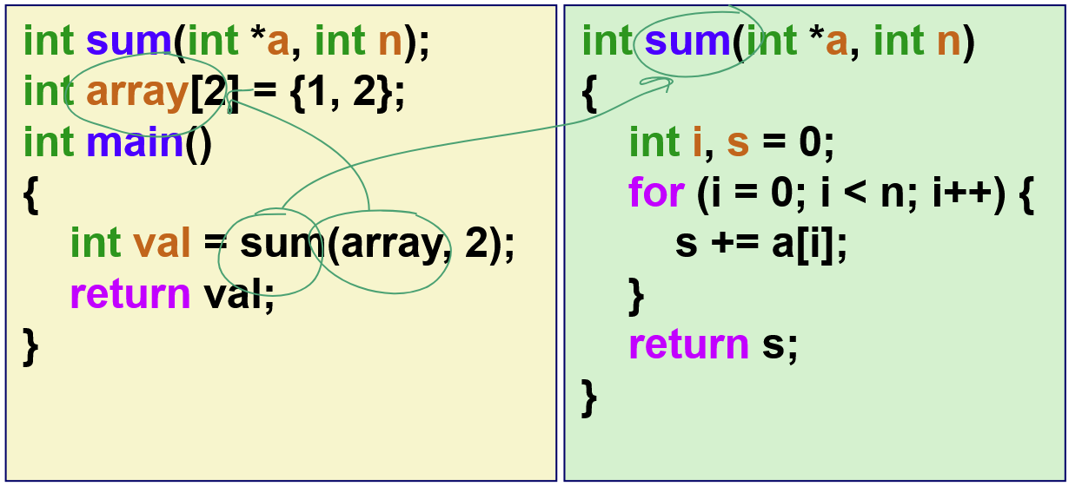

Symbol resolution: Linker uses the symbol table, found in the .o files, to resolve references
- The linker associates each symbol reference with exactly one symbol definition (not declaration)
- val, a, i, n and s are ignored (local variables)

The unique case of static local variables:
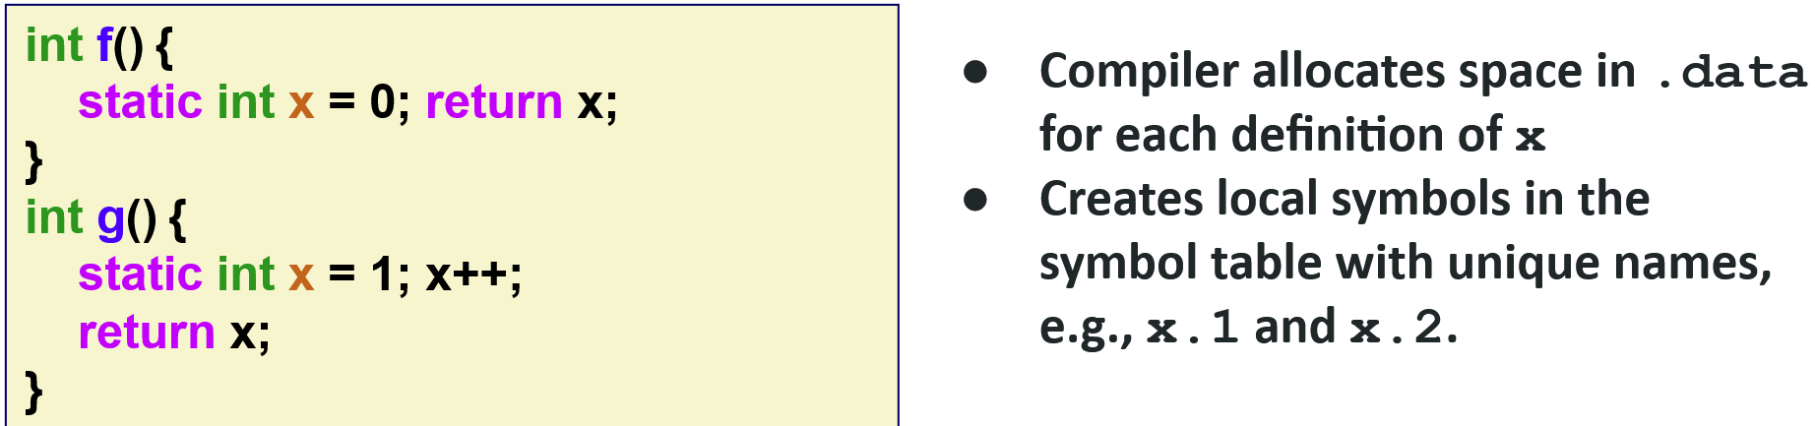
First call of g(): returns 2. Second call of g(): 3. Defined once, cannot be redefined

Strong vs weak symbols

- Weak: Uninitialized global variables
- Strong: Everything else (functions and initialized globals)
int foo = 5; // Strong
int bar; // Weak
void q() {} // Strong
The rules concerning this:
- Rule 1: Multiple strong symbols with the same name are not allowed. Throw linker error
- Rule 2: References to the strong symbol (if any) are preferred over any weak symbols
- Rule 3: If there are multiple weak symbols, pick an arbitrary one

An example below:
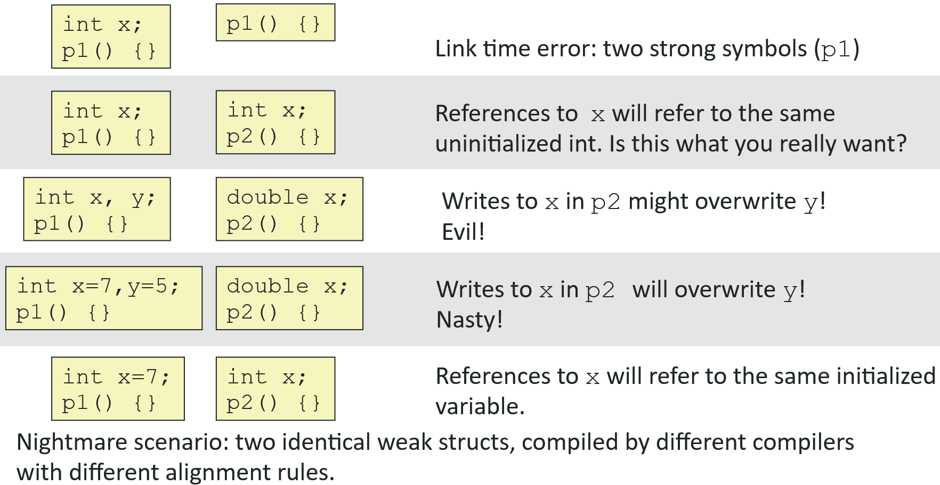

In the 4th one, the file p2 knows that x is a double and will write to x in the p1 file. It WILL overwrite y. Whereas in the 3rd one, the int or double x is randomly chosen, so it might work

Takeaway: Don’t use global variables
- If you must, use static
- If it must be used elsewhere, make it strong
- Use extern if you reference an external global variable

Relocation

Relocation: Linker merges separate code and data sections into a single section
- Relocates symbols from their relative addresses in the .o files to their final absolute memory addresses in the executable
  - Compiler and assembler assume that memory addresses start at 0
- Updates all references to these symbols to reflect their new positions

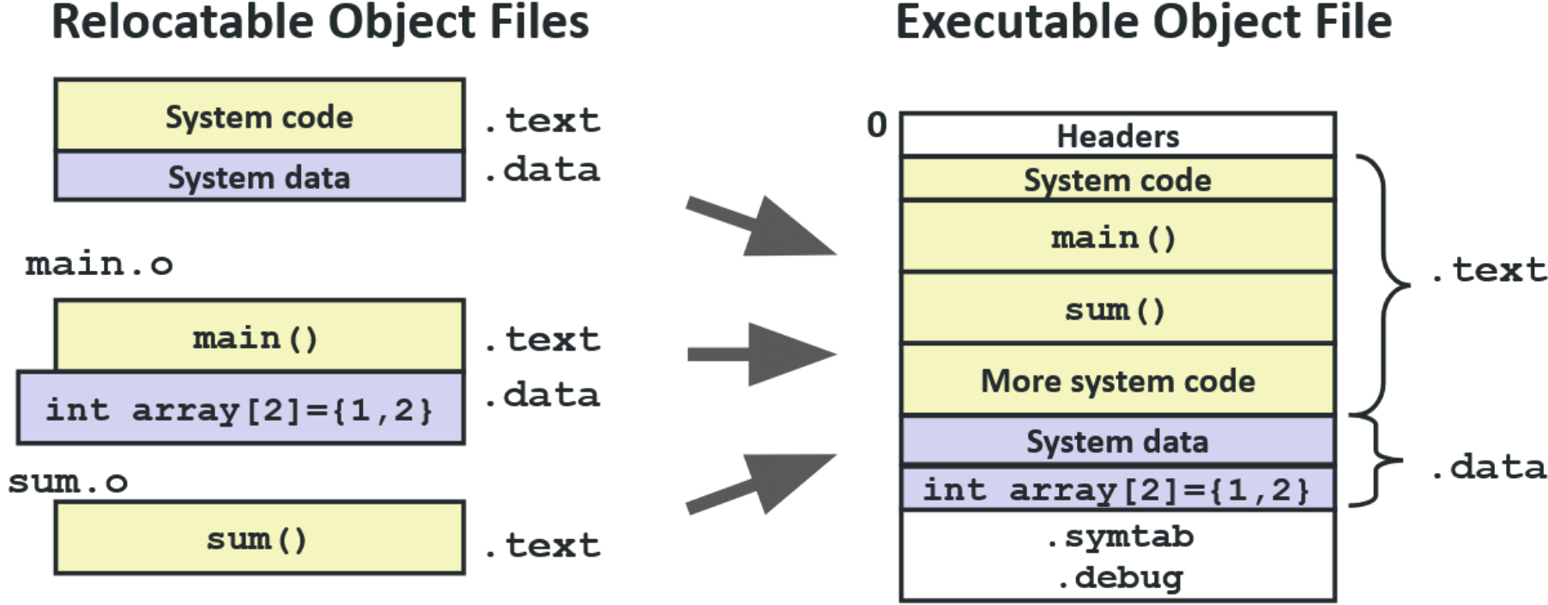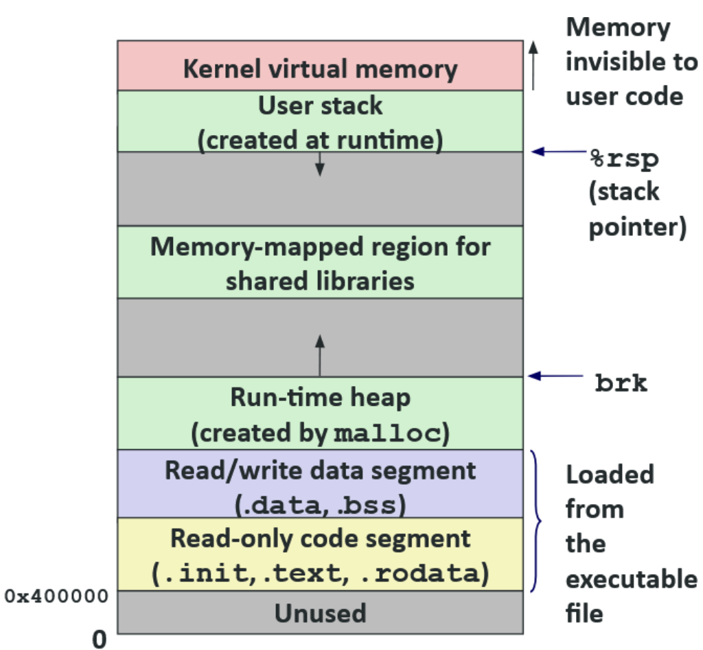

Libraries

Libraries are stored in the archive format .a
When the linker finds a reference symbol it doesn’t have, it will check the libraries and copy only the object files from the needed symbols
Below is how they are made
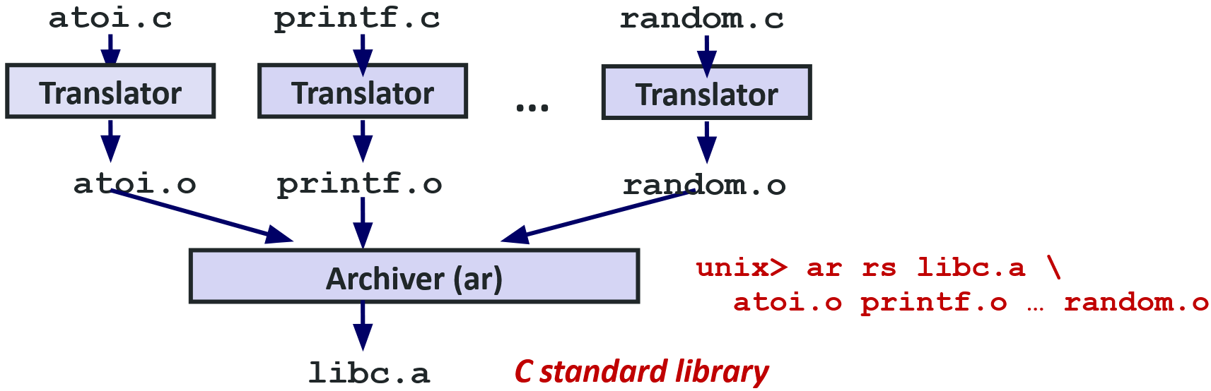
There was stuff about dynamic linking, but we breezed through it

Position-independent code:
- Flag -fpic: Compile and link code without needing the ELF to start at address 0
- Larger (and possibly slower) code, but you can create a system object that can be dynamically linked outside of your program’s ELF file
- Skips relocation passes and allows programs to be loaded at arbitrary memory locations

Linkers work at any of the following:
- Compile time (when program is compiled)
- Load time (when a program is loaded into memory)
- Run time (while a program is executing)

